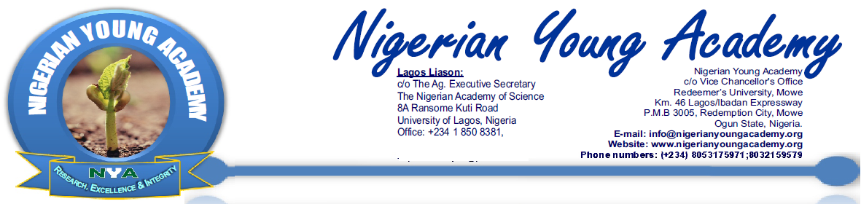

Professor Kayode Adebowale National Young Scientist Prize in Chemical Sciences

A Nigerian Young Academy National Prize in Chemistry

Application Form 2018

The Nigerian Young Academy (NYA) was established on 30th of August 2010 by the pioneering effort of the Nigerian Academy of Science (NAS), supported by Nigerian Academy of Education (NAE) and the Nigerian Academy of Engineering (NAEng). The NYA was established to provide recognition for excellence and raise the profile of young researchers in Nigeria. Additionally, members play a crucial role as inspirational figures for a new generation of researchers and impact on the society through their research. The NYA is the unified platform for the exchange of ideas across disciplines and regions, nurturing outstanding and aspiring youthful researchers and professionals towards improving the state of the nation.

In line with her objectives, the NYA, through the kind donation of Prof. Kayode Adebowale established the “Professor Kayode Adebowale National Young Scientist Prize in Chemical Sciences” with a view to promoting original research in Chemistry especially among young scientists in Nigeria. This initiative commenced in 2014. The prize is open to both male and female young researchers in all areas of research in chemical sciences. The prize is designed to recognize the scientific achievements of young researchers working in the field of Chemistry and living in Nigeria; and to encourage them to continue to strive for excellence in their research endeavours.

The prize will be presented annually and consists of a award certificate and ₦50,000 (fifty thousand Naira only) prize money. The Nigerian Young Academy is responsible for administering this prize in Nigeria, and her decisions shall be final. The prize shall be presented to the prize winner at the General Assembly/National Conference of the NYA in 2018. The date, place and details of the ceremony will be communicated to the prize winner.

Selection Details
- Candidate should not be older than 45 years of age by May 31st 2018.
- Candidate should show scholarly research in the field of Chemistry and must be affiliated to a not-for-profit research institution in Nigeria (e.g. Universities or Research Institutes).
- Only Nigerian citizens who have lived and worked in Nigeria for at least the last 3 years will be considered.
- Candidates must hold at least a Master’s degree (M.Sc. in any area of Chemistry) and have a good record of research publications in reputable peer-reviewed Journals.
- Candidates could be nominated by his/her institution. Self nomination will also be accepted.
- Once a winner is selected by the panel of judges, the profile and scientific achievements of the prize winner will be placed on the NYA website. The result of the selection will be announced on or before June 30th 2018.
- The prize winner will be expected to make a presentation of his/her research work to a general audience, during the General Assembly/National Conference of the NYA, after the award ceremony.
- Members of NYA are excluded from competing for this prize. Persons who have applied for this prize are not eligible to apply for NYA membership in the year they have applied for the prize.
- Applicants can apply for only ONE NYA prize for the year. Multiple applications from same applicant for different NYA prizes will all be automatically disqualified.
- Each application should include names of three referees who should be asked by the candidates to write with their institution’s letterhead directly by email (confidentially) to the organizers before the deadline for submission.

IMPORTANT INFORMATION
Important Information:
*Ensure that you read carefully this application form, FILL AND SUBMIT ELECTRONICALLY. SCANNED APPLICATIONS WILL AUTOMATICALLY BE REJECTED.

* Please attach the statement of result or certificate for the most recent qualification and other supporting documents, such as research awards/scholarships/fellowships/grants, NYSC certificate, etc.

*Kindly attach your current Curriculum Vitae.

*Please DO NOT exceed the number of words where stipulated.

*Deadline for submission of completed application form is Friday 30th March, 2018.

* Kindly forward completed application form with relevant documents to nyacademy1@gmail.com and cc: admin@nas.org.ng

Nominator’s details
Full Names (Surname in Capital letters):
Position/Title:
Address (Institution)
Phone: |  |  |  | Email:
Signature: |  |  |  | Date:
PERSONAL DETAILS OF NOMINEE
Full Names (Surname, Other Names; in Capital letters):
Position/Title:
Date of Birth: |  | Sex: |  |  | Marital Status:
Current Address (Institutional):
City: |  | State: |  |  | Nationality:
Email: |  | Telephone:

Educational instituton (With dates)
First Degree: | College/institution: |  |  | Year of Graduation: |  | Class:
Second Degree: | College/institution: |  |  | Year of Graduation: |  | Class:
Third Degree: | College/institution: |  |  | Year of Graduation: |  | Class:
Professional Qualification: | College/institution: |  |  | Year of Graduation: |  | Class:
Specialization:
NOMINEE’S ACADEMIC CAREER DETAILS (a complete curriculum vitae should be attached as a separate file)
Statement on nominee’s research activity (provide a brief statement on the nominee’s research activities as it would appear on a citation). A maximum of 500 words

Five Most Significant Publications in the last 3 years (listing details such as year of publication, publisher, volume, issue and page numbers) and the nominee’s contribution to each publication:

Scholarships, Fellowships and Awards (Not conference supports or awards by student bodies):

List of Publications (starting from the most current and listing details such as authors, title of publication, journal/ publisher, year of publication, volume, issue and page numbers):

List of Conference(s) Attended in the Past Three years /Papers presented (if any):

Write-up on the nominee’s suitability for the prize (a maximum of 1000 words):

Other Activities
Academic:
Non- Academic:
Membership of Professional Bodies/Key role(s):

Referees
One of these Referees should be your Academic supervisor/instructor. Do ask referees to send their support letters directly to nyacademy1@gmail.com and cc: admin@nas.org.ng
Name/Address: |  |  | Email and Phone:
Name/Address: |  |  | Email and Phone:
Name/Address: |  |  | Email and Phone:
Forward completed application form with relevant documents to nyacademy1@gmail.com cc: admin@nas.org.ng,

